Biomedical Image Informatics

Chest X-ray Pneumonia Classification Using CNN Project Report

Name | ID
Martina Alfred Aniss | 2022170888
Jana Mohamed El Saeed | 2022170886
Fatma Mostafa Abd Al Galeil | 2022170887
Mahmoud Mohamed Mahmoud | 2022170940
Mohamed Ibrahim Mohamed Bakri | 20191701157
David Wagiuh Wadie | 20191701070

Problem Description
The goal of this project is to process pediatric chest X-ray images and classify each image as either NORMAL or PNEUMONIA. The work is divided into two stages. Stage 1 explores classical biomedical image processing methods such as normalization, smoothing, edge detection, masking, segmentation, and feature extraction. Stage 2 trains convolutional neural networks on raw and preprocessed images, then compares their classification performance.

Dataset Description
The dataset contains grayscale chest X-ray images organized into train, validation, and test folders with two classes: NORMAL and PNEUMONIA. Images were resized to 128 x 128 pixels before CNN training. The sample image used for processing analysis has shape 824 x 1544, float32 data type, intensity range 0 to 255, and mean intensity 162.66335.
Split | NORMAL | PNEUMONIA | Total
Training | 3678 | 4194 | 7872
Validation | 858 | 858 | 1716
Testing | 244 | 404 | 648

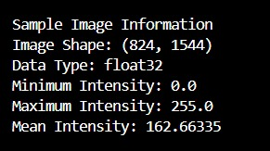
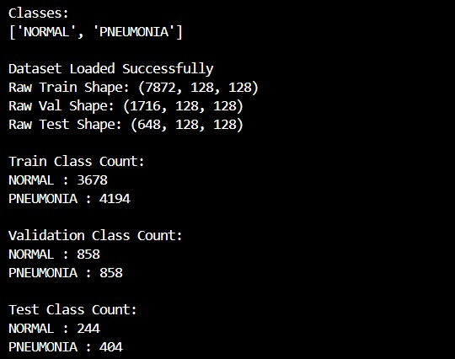
Figure 1. Dataset loading summary and class counts. Figure 2. Sample image metadata

Stage 1 Results: Image Processing and Feature Extraction
Stage 1 examined the visual and statistical properties of the X-ray images. The original image and histogram show the broad grayscale intensity distribution typical of radiographs. Normalization scaled intensities into a consistent range, which supports comparison between images and prepares the data for neural network training.
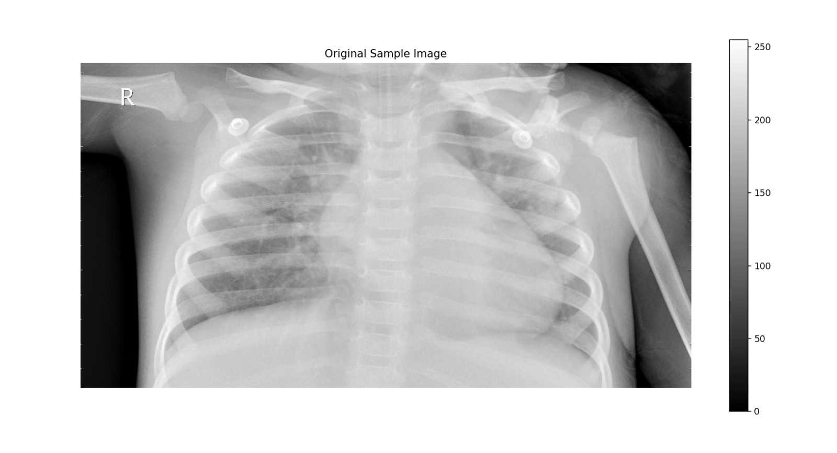
Figure 3. Original sample chest X-ray image.
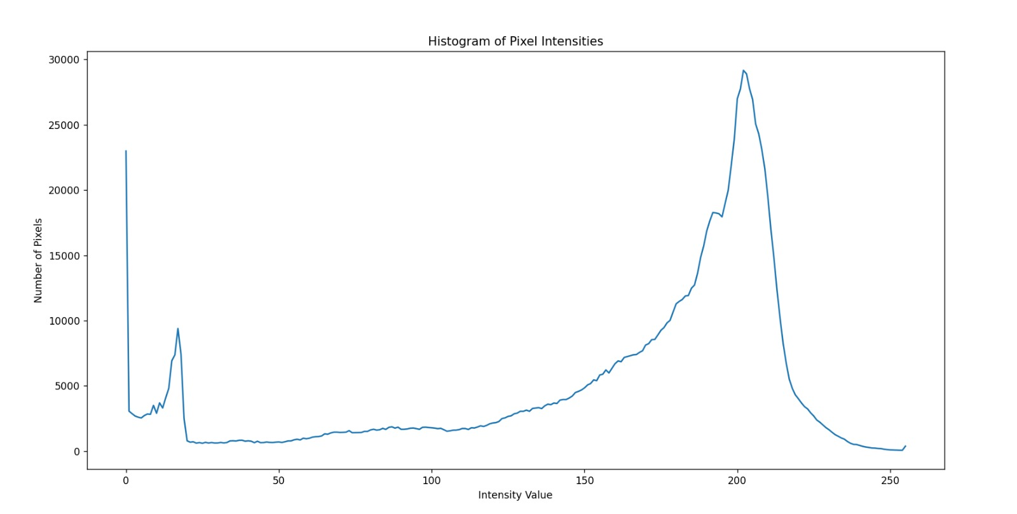
Figure 4. Histogram of pixel intensities for the sample image.
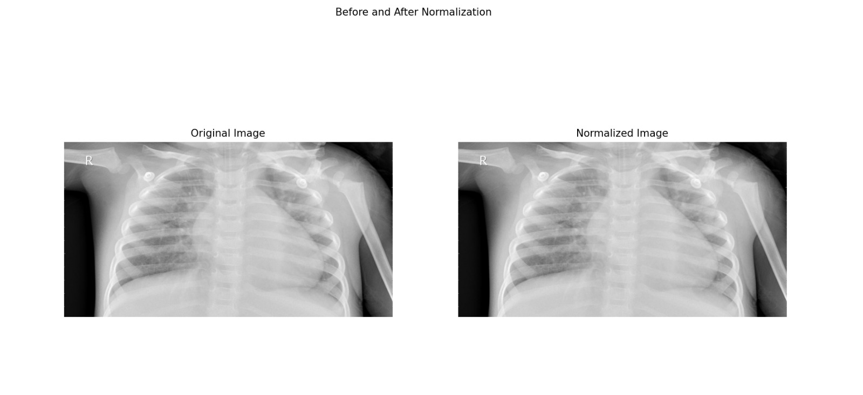
Figure 5. Before and after normalization.
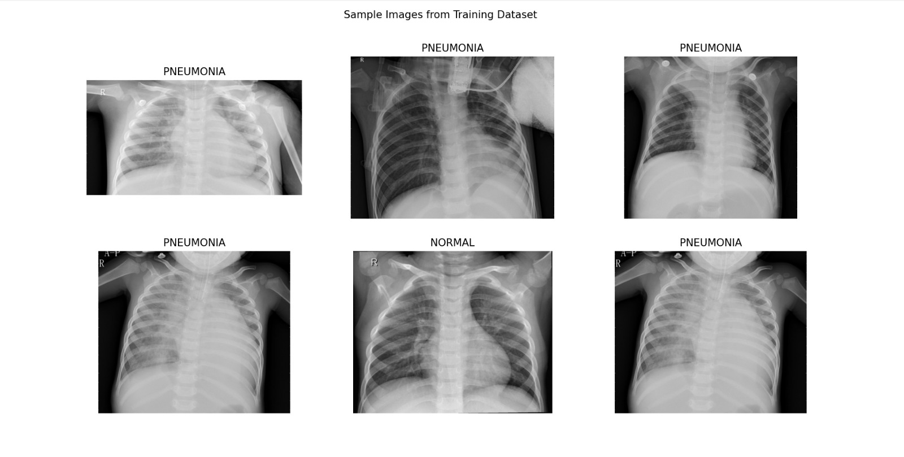
Figure 6. Sample images from the training dataset.
Filtering and edge detection were used to study structure in the radiographs. Gaussian, mean, and median filters reduced noise with slightly different smoothing behavior. Sobel and Prewitt emphasized boundaries such as ribs and lung edges, while the Laplacian response was weaker for this image because it is more sensitive to fine intensity changes and noise.
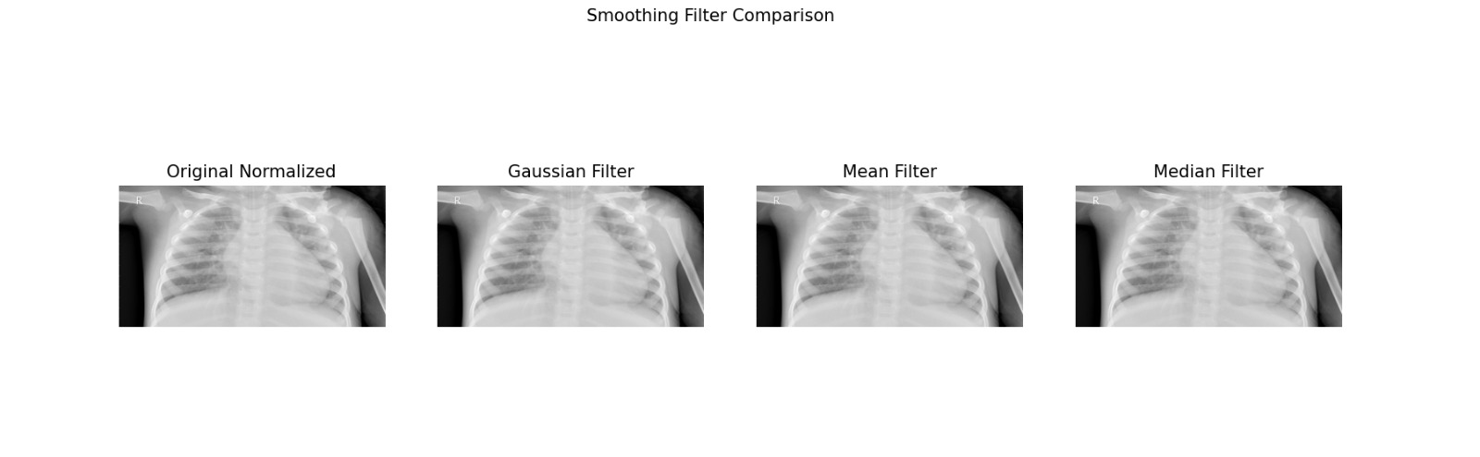
Figure 7. Smoothing filter comparison.
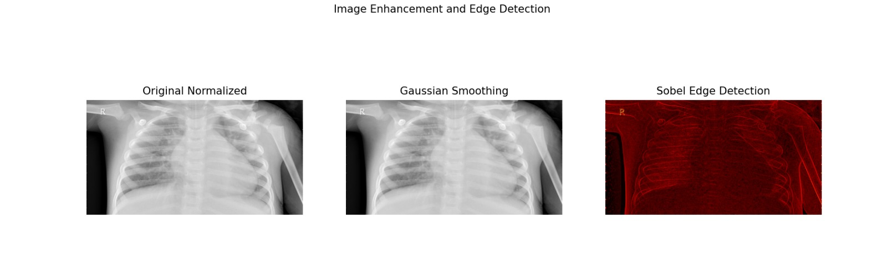
Figure 8. Image enhancement and Sobel edge detection.
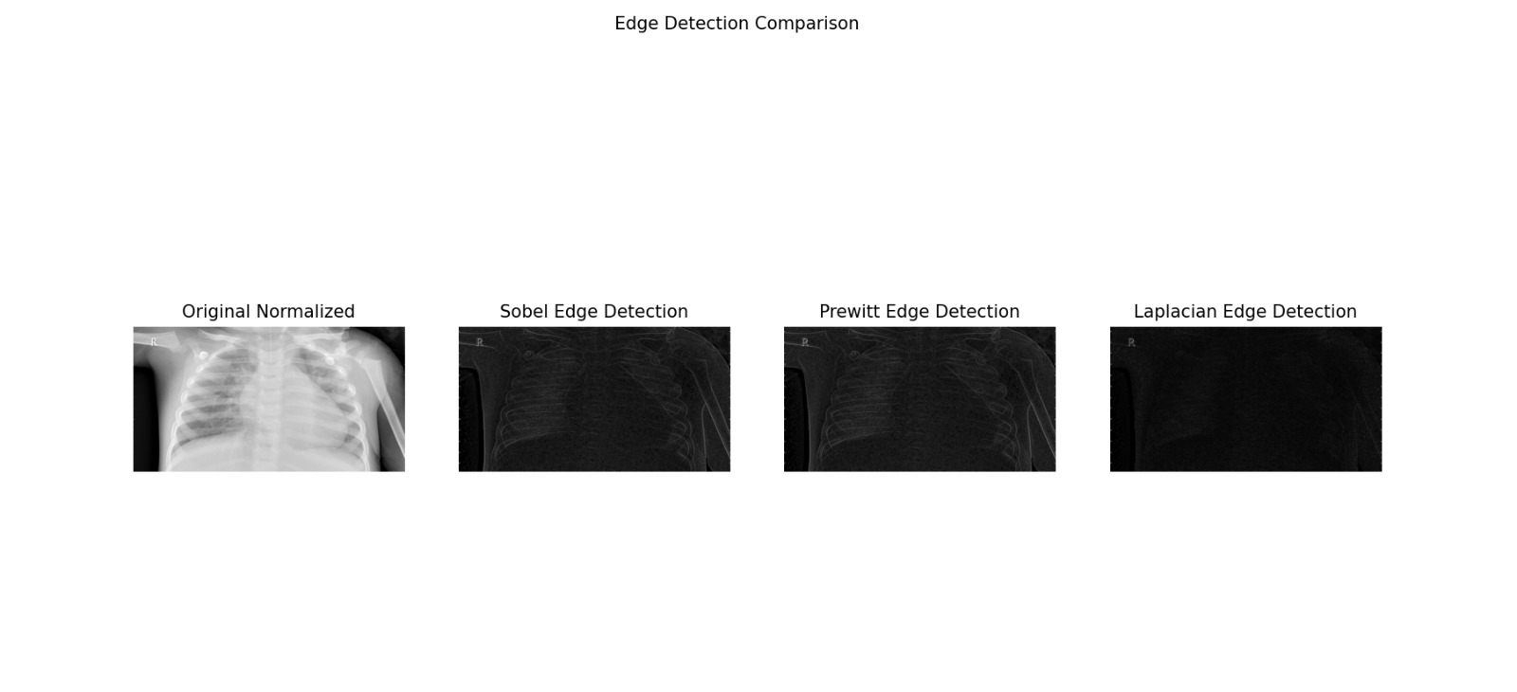
Figure 9. Edge detection comparison using Sobel, Prewitt, and Laplacian operators.
Segmentation was tested using mean thresholding, percentile thresholding, and Otsu thresholding. The produced masks show that simple thresholding can capture broad bright regions but may also include non-lung structures. The extracted feature plot shows overlap between classes.
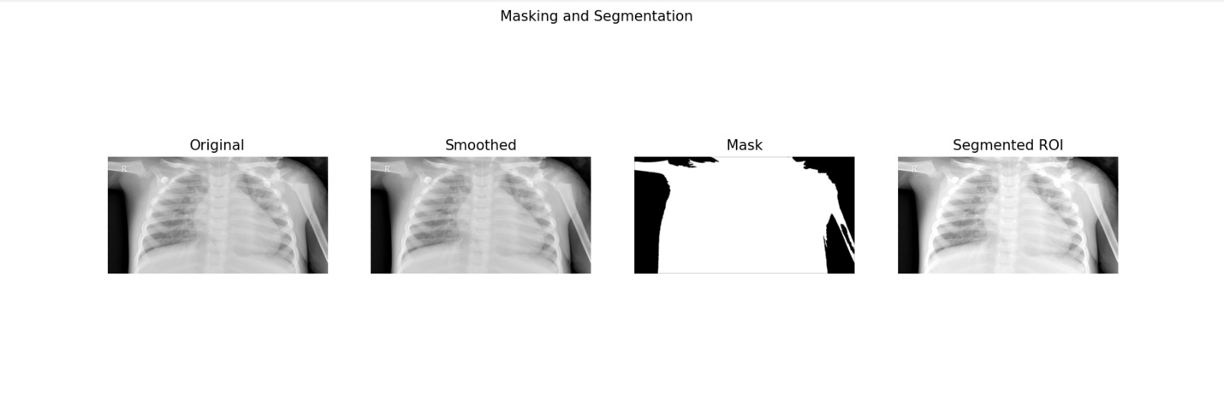
Figure 10. Masking and segmentation result.
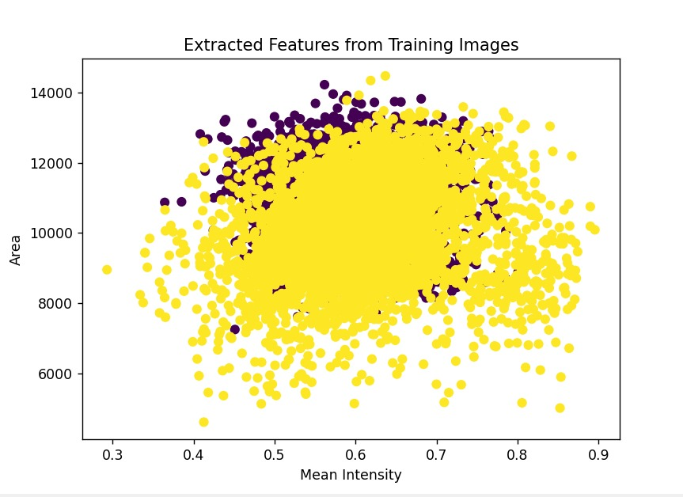
Figure 11. Masking methods comparison.
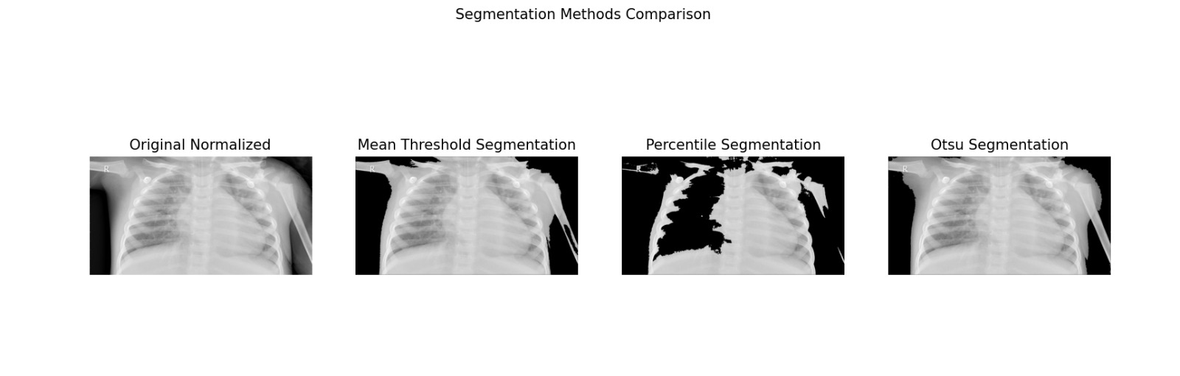
Figure 12. Segmentation methods comparison.
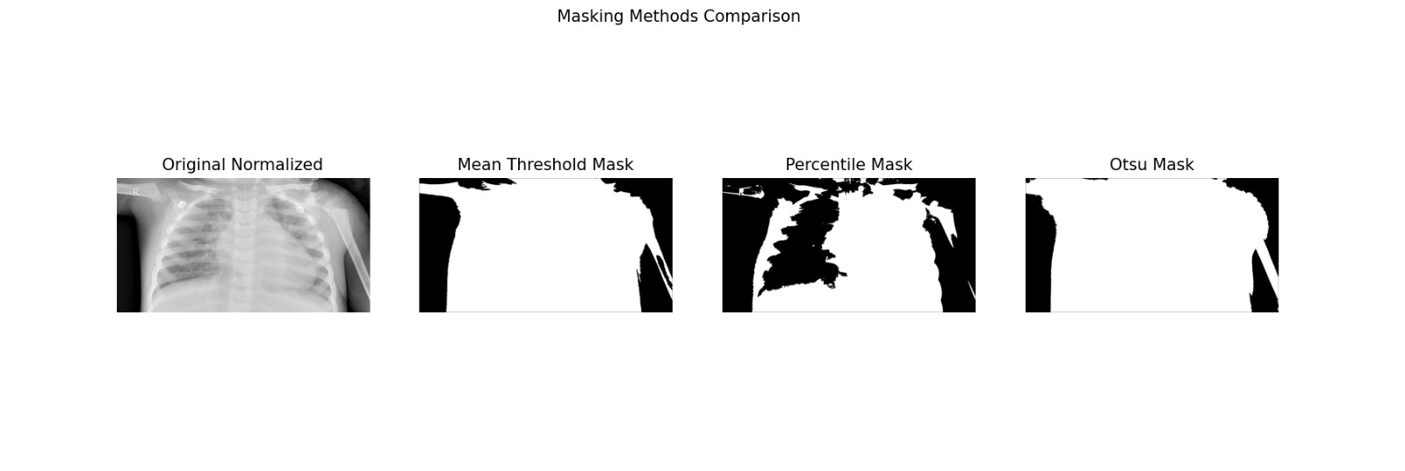
Figure 13. Extracted features from training images.

Stage 2 Results: CNN Classification
Two CNN experiments were performed. The first model was trained on raw normalized images, and the second model was trained on preprocessed images. Both models used three convolutional blocks followed by flattening, a dense layer, dropout, and an output layer. Cross-entropy loss and the Adam optimizer were used for training.
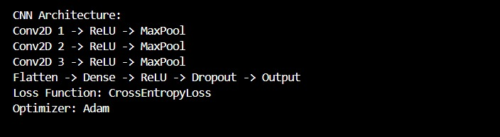
Figure 14. CNN architecture summary.
Experiment | Accuracy | Precision | Recall
Raw Images | 0.8688 | 0.8916 | 0.8688
Preprocessed Images | 0.9028 | 0.9148 | 0.9028

The preprocessed model achieved the better overall result, improving accuracy from 0.8688 to 0.9028 and weighted precision from 0.8916 to 0.9148.

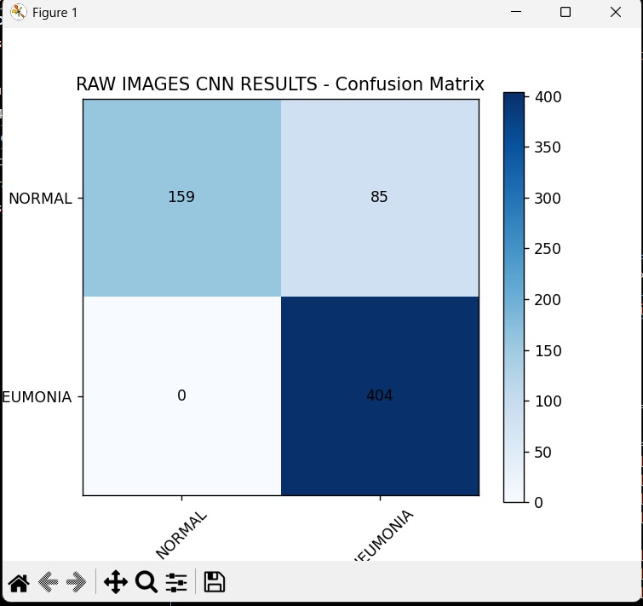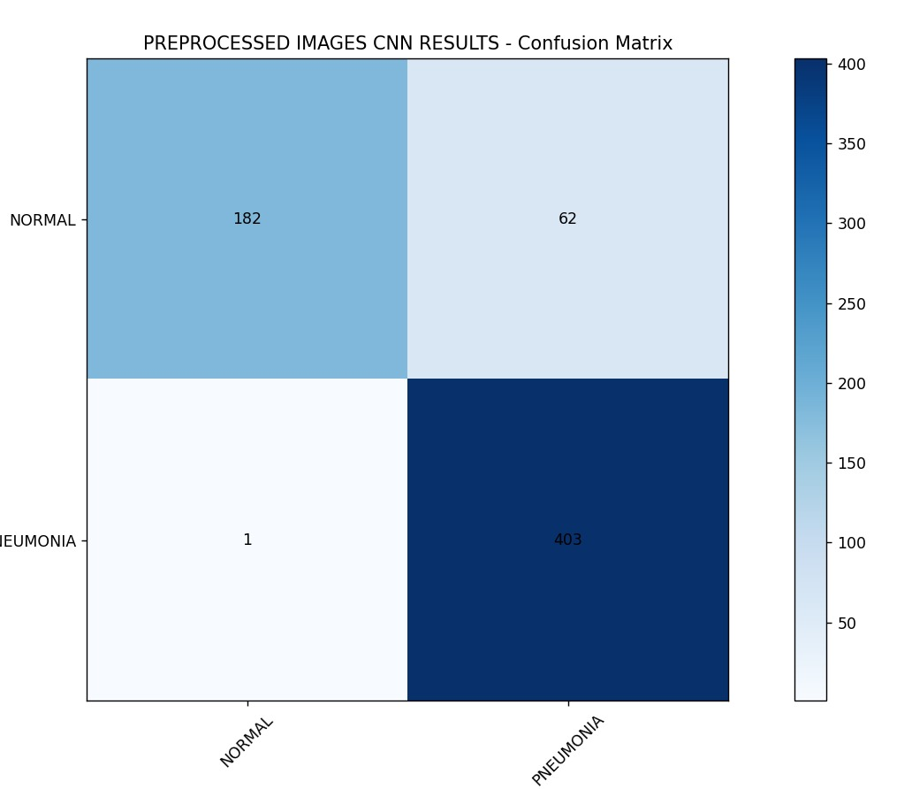

Model | TN | FP | FN | TP
Raw Images | 159 | 85 | 0 | 404
Preprocessed Images | 182 | 62 | 1 | 403

The confusion matrices show that both models correctly detected almost all pneumonia cases. The preprocessed model reduced false positives for NORMAL images from 85 to 62, while introducing only one false negative pneumonia case.
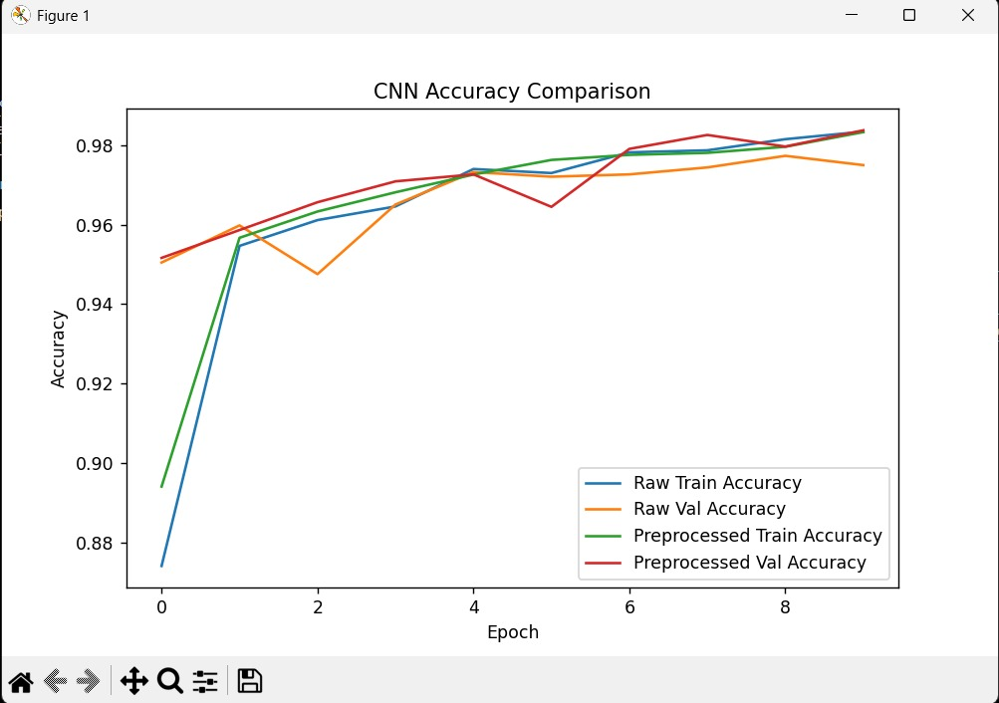
Figure 15. Raw images CNN printed classification results.

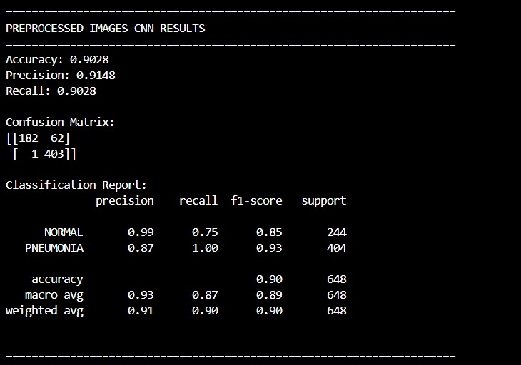
Figure 16. Preprocessed images CNN printed classification results.

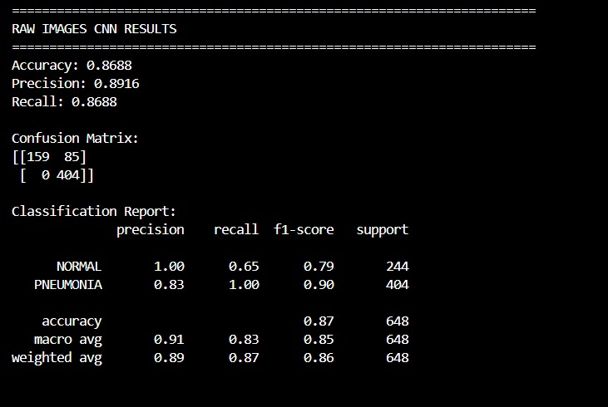
Figure 17. CNN training and validation accuracy curves.
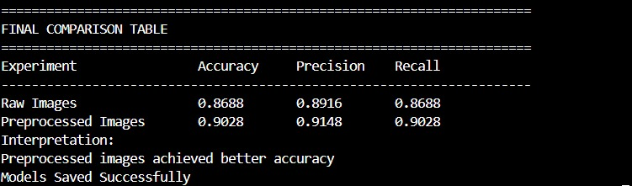
Figure 18. Final comparison table

Discussion and Conclusions
The Stage 1 image processing experiments helped explain how preprocessing changes the visual information available to the classifier. Normalization standardized pixel intensity ranges, smoothing reduced noise, and edge detection highlighted anatomical boundaries. However, simple segmentation masks were not perfectly focused on lung regions, so extracted area and mean intensity showed strong class overlap.
The Stage 2 CNN results show that preprocessing improved classification performance. The preprocessed-image model produced higher accuracy, precision, and recall than the raw-image model. The most important improvement was the reduction in NORMAL images incorrectly classified as PNEUMONIA. Overall, the experiment supports the conclusion that preprocessing can improve CNN performance for this chest X-ray classification task, although future work could improve segmentation quality, use augmentation, and evaluate more advanced pretrained CNN architectures.

